Question 1a - SVM

**C = 0.5, kernel = ‘rbf’, gamma = 0.5**

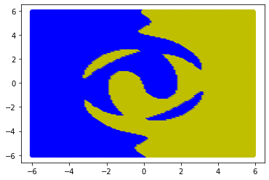

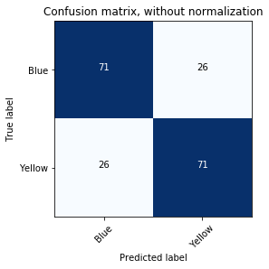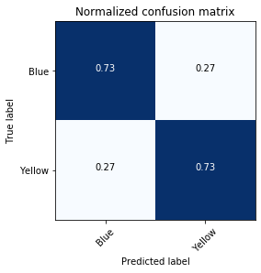

Model accuracy: 73.19587628865979 %

sensitivity = 0.7319587628865979

specificity = 0.7319587628865979

precision = 0.7319587628865979

recall = 0.7319587628865979

**C = 0.5, kernel = ‘rbf’, gamma = 0.75**

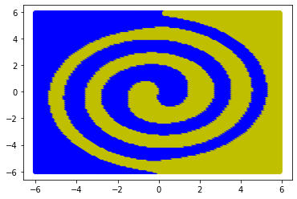

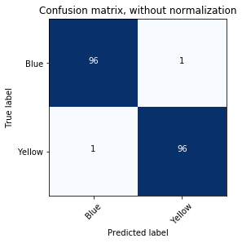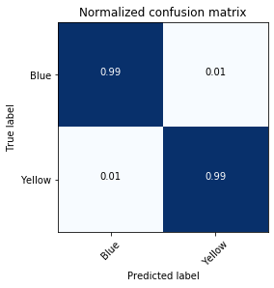

Model accuracy: 98.96907216494846 %

sensitivity = 0.9896907216494846

specificity = 0.9896907216494846

precision = 0.9896907216494846

recall = 0.9896907216494846

**C = 0.8, kernel = ‘rbf’, gamma = 0.75**

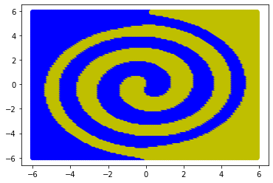

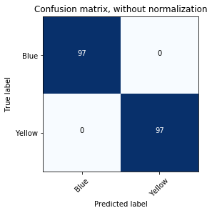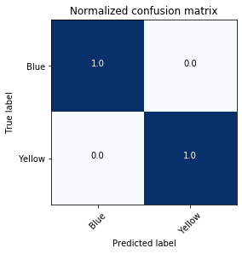

Model accuracy: 100.0 %

sensitivity = 1.0

specificity = 1.0

precision = 1.0

recall = 1.0